JOHN’S SECOND EPISTLE
“That you may be rewarded fully”
16 June 2024
Download from http://1john.currah.download
Chiasmic structure of 2 John
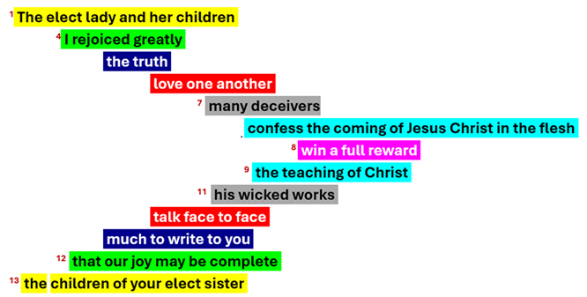
Who was the author?
● He calls himself ‘the elder’.
● Ancient writers said it is the Apostle John (for examples, Irenaeus, AD 130-202, and Clement of Alexandria, AD 150-215).
● Some early churches doubted that 2 John was authentic, but later accepted it.
● There remain 22 ancient manuscripts containing 2 John, some from the 4th, 5th and 6th centuries.
What was the problem?
● In 1 John, some Christians left the church and became false teachers, denying that Jesus was the Messiah (Christ). 1 Jn 2:19
● In 2 John, false teachers have gone out into the wider world. 2 Jn 7
● In 3 John, there are unfriendly church leaders who dominate the Christians. 3 Jn 9
Background
● John was one of Jesus’ 12 appointed apostles, and an eyewitness to Jesus’ baptism, teaching, miracles, transfiguration, and resurrection.
● John earlier wrote the Gospel of John, demonstrating that Jesus was both God in human flesh, and the awaited Messiah.
● John later dwelt at Ephesus where he served as chef “elder” over many churches.
● In the early centuries, as in many countries today, Christians often gathered in homes as small “daughter” churches that belonged to a big “mother” church.
● The Christians were now in their 2nd and 3rd generations, and had been multiplying churches in many regions.
● Some Jewish missionaries were teaching that Jesus was not a real Messiah (Christ).
● Some Gentile’s were teaching that Jesus was only human, and that “Christ” was a spirit that came to Jesus, and later left him.
2 John 1
¹ The elder, To the lady chosen by God and to her children, whom I love in the truth — and not I only, but also all who know the truth —
● Elder:  ● Lady:  ● Chosen:  ● Children:  ● In truth: | He pastored a church network.  A “daughter” church or cell.  Believers join the Chosen One.  Christian church members.  ‘Truly’ or ‘by (teaching the) truth’.
2 John 2-3
² — because of the truth, which lives in us {you} and will be with us {you} forever: ³ Grace, mercy and peace from God the Father and from Jesus Christ, the Father’s Son, will be with us {you} in truth and love.
● Truth:  ● Lives:  ● Forever:  ● And love: | “I am the Way, Truth and Life!”  He remains. (People leave him!)  ‘Until the age (to come)’.  “Speak the truth in love.”
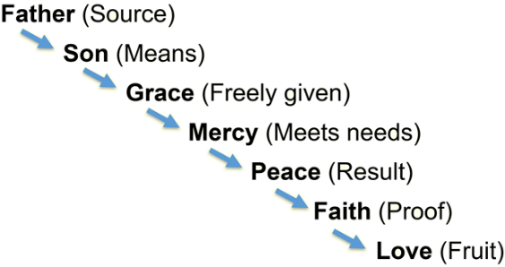
2 John 4
⁴ It has given me great joy to find some of your children walking in the truth, just as the Father commanded us. NIV
● Joy:  ● Some:  ● Walking:  ● Command: | Gladness that comes from God.  Others prove rebellious.  Obeying Jesus’ commandments.  “Listen to him!” Luke 9:35
2 John 5
⁵ And now, dear lady, I am not writing you a new command but one we have had from the beginning.
I ask that we love one another.
● Colored:  ● We:  ● Love:  ● Another: | Supplied by translators.  1. Apostles, 2. Christians.  Loyal obedience, meeting needs.  Stay connected with a church.

2 John 6
⁶ And this is love: that we walk in obedience to his commands. As you have heard from the beginning, his command is that you walk in love.
● Obedience: | Proof of loyal faith in Jesus.
● Commands:  ● Heard:  ● You:  ● Love: | Which can you recall?  Before false teachers spoke.  Christians who heard apostles.  Love: God, others, enemies.
2 John 7
⁷ I say this because many deceivers, who do not acknowledge Jesus Christ as coming in the flesh, have gone out into the world. Any such person is the deceiver and the antichrist.
● Deceivers:  ● Jesus:  ● Christ:  ● Flesh:  ● Antichrist: | Mix truth with untruths.  Human name.  God’s promised King.  Real humanity, not a spirit.  Pretend substitute.
“Jesus Christ as coming in the flesh”
Greek grammar: ‘predicate complement’.
Confess: Jesus = Christ + coming in flesh.
● Confess “Jesus was the Christ come in human form” or
● Confess that Jesus was the Christ… or
● Confess Jesus as the Christ in human form.
Jesus was the Christ. The Christ was not a spirit that came to Jesus and later left him.
Other lies about Jesus
● Jesus never existed. He was ‘made up.’
● Jesus never claimed to be the Messiah.
● Jesus never claimed to be God or divine.
● Jesus failed, so another messiah must come.
● Jesus was a ‘great master’ like Buddha.
● Jesus was an angel in human form.
● Jesus was one of God’s physical sons.
● Jesus was a prophet who never died.
● Jesus is an extraterrestrial alien.
2 John 8
⁸ Watch out that you do not lose what we have worked for, but that you may be rewarded fully.
● Watch out:  ● Lose:  ● We:  ● You:  ● Rewarded: | Everyone has an opinion.  All must give an account.  Church leaders want you to win.  Who believe in Jesus Christ.  (1) Everlasting life, (2) rewards.
2 John 9
⁹ Anyone who runs ahead and does not continue in the teaching of Christ does not have God; whoever continues in the teaching has both the Father and the Son.
● Ahead:  ● Teaching:  ● God: | Or ‘runs away’.  (1) What Jesus taught, or (2) Teaching about Christ (v 10).  One True God = Father + Son.

2 John 10-11
¹⁰ If anyone comes to you and does not bring this teaching, do not take them into your house or welcome them. ¹¹ Anyone who welcomes them shares in their wicked work.
● Teaching:  ● House:  ● Welcome:  ● Work: | Christology, not Eschatology.  House churches in homes.  Compromise with falsehood.  Doctrines ➔ deeds.
2 John 12
¹² I have much to write to you, but I do not want to use paper and ink. Instead, I hope to visit you and talk with you face to face, so that our joy may be complete.
● Write:  ● Paper:  ● Talk:  ● Joy: | First John?  Likely parchment (skins).  Understanding requires feedback.  Dying rich men regret their children.

… | …

… | …

