Introduction to the Vocal Apparatus
Introduction to English vowels and consonants

In preparation for this lesson read
- Class Manual pages for Day 2

Optional Reading:
- https://en.wikipedia.org/wiki/IPA_vowel_chart_with_audio
- https://en.wikipedia.org/wiki/IPA_pulmonic_consonant_chart_with_audio
- http://www.slideshare.net/richardbinkney/phonology-the-sound-patterns-of-language-made-easy
__________________________________________________________________

Objectives
- Become familiar with the vocal apparatus and the points of articulation
- Learn the benefits of using charting tools to help learners understand language sound systems and solve pronunciation problems.
- Pronounce English consonants and find them in a phonetic chart
- Pronounce English vowels and find them in a phonetic chart
- Employ phonetics tools using English as an introduction to the phonetic system of another language.
Terms and Definitions
Articulator: a movable organ, such as the tongue, lips or uvula, the action of which is involved in the production of speech sounds.

Points of Articulation: the place at which two speech organs approach or come together in order to produce a speech sound, such as when the tongue and teeth come together to form a dental sound.

Consonant Sounds: sounds made when air flow through the throat, mouth or nose
is interrupted or limited by the tongue, teeth or lips.

IPA: International Phonetic Alphabet. A system of phonetic notation created by linguists to accurately and uniquely represent each of the wide variety of sounds (phones or phonemes) used in spoken human language. (Wiktictionary)
Vowel Sounds: Sounds made by shaping the oral cavity while air is coming relatively unobstructed from the lungs.
Class Notes: This sheet is designed for taking notes in class. Here are some of
the topics we will be discussing during our session.

- English phonetics can help us learn another language’s sounds.

- Points of articulation: human speech apparatus.

- Mapping English vowels and consonants in charts.

- Pronunciation of English vowels.

- Pronunciation of English consonants.

- The importance of facial muscle, lip and tongue training and exercise to gain effortless sound production. (Try holding a pencil between your front teeth while pronouncing words and sentences.)

- Find our way around in standard IPA vowel and consonant charts.

WORKSHEET 1 – The Vocal apparatus: Points of articulation

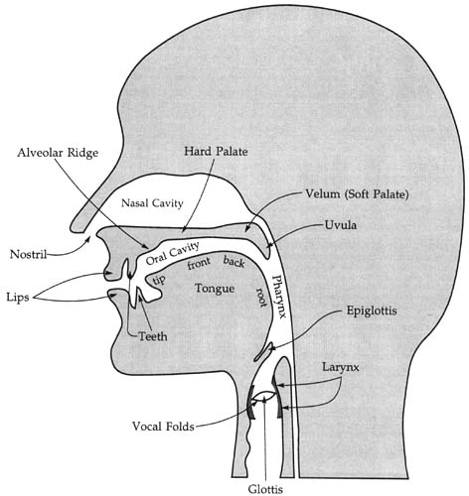
http://www2.leeward.hawaii.edu/hurley/Ling102web/mod3_speaking/3mod3.5.2_place.htm

Pronounce the following words, one at a time, feeling in your mouth and nose, where each word’s sounds are formed: apple, berries, cantaloupe, grapes, juice, jalapenos, mandarins; sniffing, flowers, tulip, rose, roses, violets
Recognize these “points of articulation”. Note their descriptive:
Alveolus, alveolar ridge  Epiglottis, epiglottal  Glottis, glottal  Larynx, laryngeal  Lip, labial, labio-  Lips, bilabial  Nose, nasal | Palate, palatal  Pharynx, pharyngeal  Teeth, dental  Tongue, lingual  Uvula, uvular  Velum, velar  Voice, vocal, vocalized

WORKSHEET 2 – English Vowels and Consonants/Points of Articulation
Introduction: Charting tools help language learners and linguistics understand
sound systems and solve pronunciation problems.
Consonants - Compare the two axes of this table with the Points of Articulation

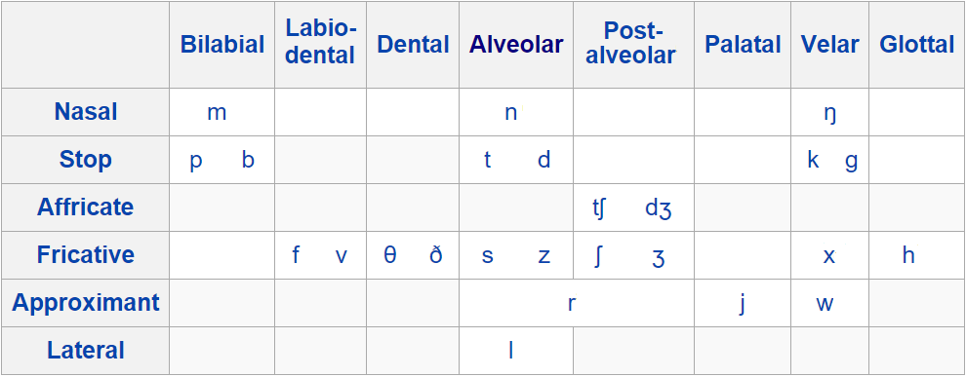

Nasal, air passes through the nasal cavity: letters m, n, ing
Stop, air flow is stopped, before or after a sound: letters b, d, g, k, p, t
Affricate, air is stopped before a fricative: letters ge, j, ts
Fricative, air is impeded during a sound: letters f, s, sh, th, v, z
Approximant, air is impeded, but not a stop or a fricative: letters r, w, y
Lateral, air passes beside the tongue whose tip touches the alveolus: letter l

Vowels
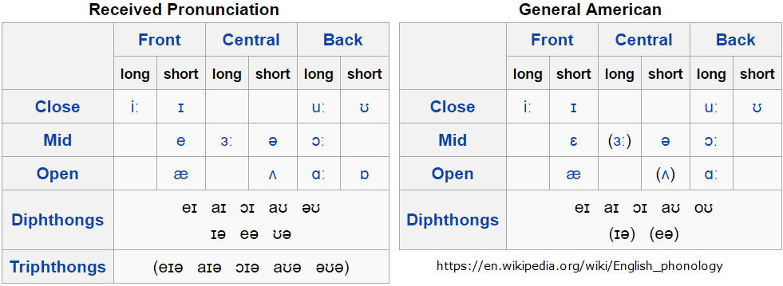
Pronounce these words. Become familiar with the phonetic transcription of vowels

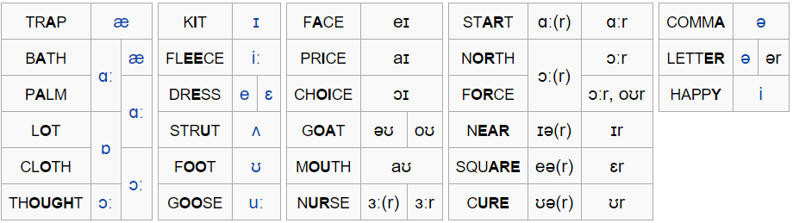

SUPPLEMENT 1 – First steps in affecting a French accent

Introduction: Learning to mimic a French accent illustrates the effects that sounds
can have on a speaking and hearing another language.

Question: Why would an American ever want to sound like a Frenchman?

1. Begin by reading or reciting aloud any text. Use the following text to get started.

Come here, little red hen. Tell me, why did you cross the road? “Just to get to the other side of the road,” replied she. Why did you put all your eggs into one basket? “They are for the queen.” Here comes the queen’s coach!
2. Read the text repeatedly, incorporating each time another of the following:
- Give every syllable in a word the same stress. E.g., “ev-er-y syl-lab-bel”.
- Avoid mid-sentence intonation. Questions intone upwards at the end of sentences, statements downwards, and commands or exclamations stay flat.
- Drop your “h” sound. E.g., “hear” sounds like “ear”.
- Replace your “r” sound with a constriction or gargle at the back of your throat.
- Pronounce “p”, “k” (“c”, “q”) and “t” softly (without aspiration).
- Replace “th” with “d” or “z”.
- Employ only “pure” vowels, without glides, slurs or diphthongs. E.g., “i”, comes out similar to “ee” as in “beet”, “out” as “ah-oot”.
- Pronounce “o” and “u” with your lips rounded as in “Ou, la, la!”
- If you know that an English word comes from French, you may choose to pronounce that word as in French.

During this exercise, how did you sound to yourself? How do you feel about yourself? Silly? Funny? Embarrassed? As a phony? As a Frog?

