INTRODUCTION TO SUPRASEGMENTALS
To prepare for this lesson read:

- Manual pages for Day 4
- Learning a New Phonological System

Supplementary Reading:

- https://en.wikipedia.org/wiki/Thai_language#Tones
- https://en.wikipedia.org/wiki/Standard_Chinese_phonology#Tonal_categories
- https://en.wikipedia.org/wiki/Intonation_(linguistics)
- https://en.wikipedia.org/wiki/Stress_(linguistics)
__________________________________________________________________
Objectives
- Become familiar with terms and definitions.
- Recognize suprasegmentals in English.
- Recognize tone in Mandarin Chinese.
- Read Chinese Pin Yin with recognizable word tones.
Terms and Definitions
Intonation: Change voice pitch in the course of speech. Languages tend to be more
intonational or more tonal.

Stress: Emphasize syllables, words or phrases by voice pitch, volume, timbre or
length.

Tempo: Meaningful change of speed in speech.

Rhythm: Amount of regularity of timing, duration or stress of syllables.

Pause: Use of sound, words or silence to – you know – highlight preceding or
following speech.

Rhythm: Sentence melody, a combination of tone, intonation and rhythm.

Segmentals: The consonants and vowels in a language’s sound system.

Suprasegmentals: Language sound phenomena such as those listed in this set of
terms and definitions.

Tone: Degree of rise and fall within a syllable or word that distinguishes it from
same phones having difference tone.
CLASS NOTES 1: This sheet is designed for taking notes in class. Here are some of the issues that we shall be discussing during our session.
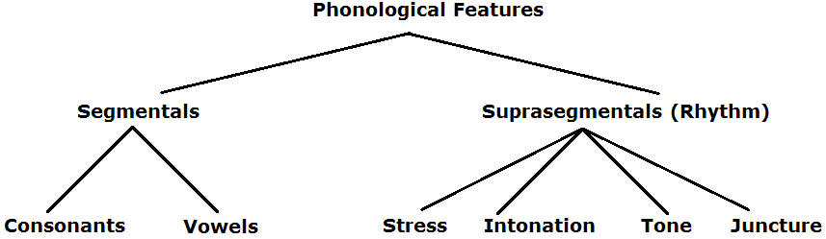
- Would it be insensitive for us to mimic native speakers’ tones and intonation, that is, the melody of their speech?

- Has our brain been designed to learn patterns through listening and mimicking, without worry, fear, effort or embarrassment?

- What will native speakers commend you more often? For your good accent and tones? Or for your correct grammar or flawless choice of precise words?

- How are actors and singers able to pronounce various accents so convincingly?

- French intonation towards the end of sentences:
- Queries tend upwards. E.g., ‘Ça va ?’
- Commands and exclamations tend to remain flat. E.g., ‘Ça va !’
- Statements tend downwards. E.g., ‘Ça va.’

Wolof statement intonation tends to remain flat, queries tend downwards, and exclamations add ‘de!’ Query: ‘Baax na?’ Exclamation: ‘Baax na de!’ Statement: ‘Baax na.’
CLASS NOTES 2 – Employ SIL’s Speech Analyzer software
- How could we compare our tones and intonation with that of native speakers?

- How could SIL’s Speech Analyzer software help by making recordings, or by reading recordings made by others?
The Raw Waveform graph displays the unprocessed sound picked up by the microphone.
The Auto Pitch graph displays a smoothed pitch contour determined by six parameters that Speech Analyzer sets to provide the best overall performance.
The Raw Pitch graph displays a pitch contour determined by three parameters that you can set.
Intensity (or physical intensity) is the instantaneous energy delivered by a sound, relative to a fixed energy level.
A spectrogram is a three-dimensional plot of the intensity of the frequency content of a signal as it changes over time.
Use the Record Overlay to mimic a previous recording, by making an overlay recording.
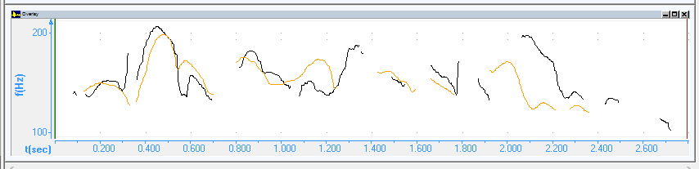
- How does your intonation compare with a native speaker’s intonation of same phrases?
- How do you sound to yourself when mimicking a native speaker?
SUPPLEMENT 1 — Mandarin Chinese tones and Pīn Yīn

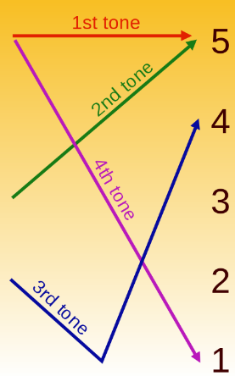 | 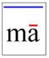1 | 2 | 3 | 4 | 5
Tones consist in a change of pitch or frequency, rather than in a change of volume or of stress. Thus, tones may be compared to notes on a musical scale.
Try reading John 3:16 in Mandarin. /sh/ & /zh/ are retroflexive; /c/ = ‘ts’.

SUPPLEMENT 2 — Central Thai tones
