Identifying and Addressing Pronunciation Issues
To prepare for today’s lesson read:

- Manual pages for Day 6
- How can I improve my pronunciation skills?

Supplementary Reading:

- http://www.slideshare.net/ajezahmad/phonetics-manner-of-articulation
- https://www.youtube.com/watch?v=TOZ0CwkRtxI
- http://www.espressoenglish.net/minimal-pairs-english-pronunciation-exercises-vowels/
- http://download.cnet.com/Minimal-Pairs-Tutor/3000-2279_4-76088070.html
- http://phonologyassistant.sil.org/

Objectives
- Become familiar with terms and definitions.
- Learn a strategy for identifying and addressing pronunciation issues.
- Learn how to train a language helper to participate with you in drills.
- Identify minimal pairs and employ these in pronunciation drills.
Terms and Definitions
Alphabet: a system of writing in which each symbol ideally represents one sound
unit of a spoken language.

drill: /drɪl/ A repetitive exercise that aims to strengthen habitual behavior.
homophone: /ˈhɒməˌfəʊn/ A word or sound pronounced the same as another but
differing in meaning, whether spelled the same way or not, as heir and air.
minimal pair: two short words that have contrasting phonemes in the same
position.

phonetic spelling: /fənɛtɪk spɛlɪŋ/ employing IPA characters to spell whole words.

Class Notes: This sheet is designed for taking notes in class. Here are some questions that we shall be answering during our session.

- Who of us plays a musical instrument? What kinds of drills have you found helpful to increase your musical skills? When did you start drilling? How long or how often was enough? The importance of working with a language tutor who can help you identify causes of persistent mistakes, and work out solutions and drills that will strengthen good habits.

- Why would it be important to get meaningful feedback from listeners, from both native speakers and experienced second-language speakers? (Those who have been through similar learning experiences can often prove good coaches.)

- What would be a benefit of knowing how to isolate and focus on one sound in order to master it?

- What are minimal pairs? What are they useful for? Where can we find some?

- How can minimal pairs be generated?
(a) Choose some phonemes that you want to be able to distinguish clearly. E.g., /g/ and /k/.
(b) Find several short words that contain those phonemes. E.g., pig, gaff, pick, calf.
(c) Choose pairs of words that have contrasting phonemes in a same position in their word. E.g., pig — pick, gaff — calf.
(d) Have a language helper speak the pairs to you, until your ear starts to distinguish them.
(e) Have your language helper speak each word in a pair and mimic it, repeating them until your mouth can distinguish them.
Some tutors advise drawing your minimal pairs from vocabulary that you have already acquired.

- English phonemes in minimal words. (http://www.minpairs.talktalk.net/minimal.html)
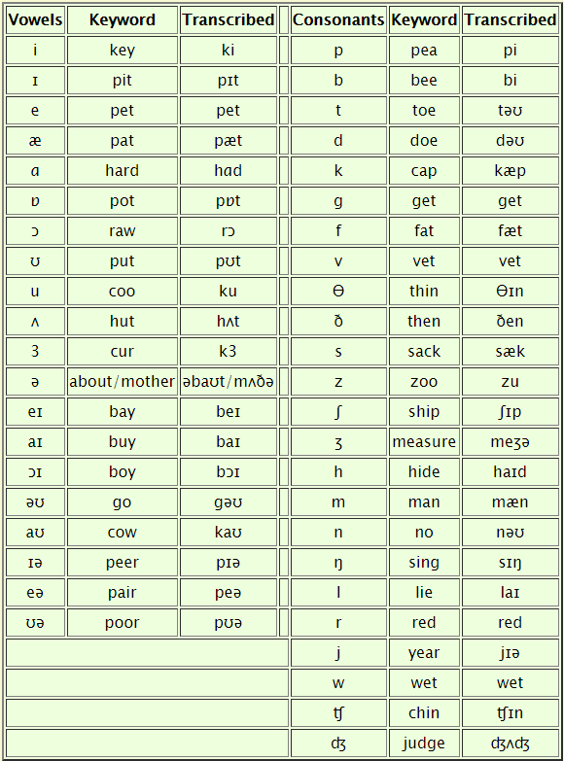

WORKSHEET 1 – Single Sound Drill
Introduction: This drill will allow you to isolate and focus your attention on sounds that are difficult to discern in your target language.

Using “th” as an example
- Say something like this to your helper: "The sound at the beginning of “the” is difficult for me. I want to collect some words with this sound and then practice pronouncing them. I have collected these two words so far:” thank, this
- What are some more words that begin with “th?" Try to get short words and transcribe them or write them in some way so that you end up with about 6-8 words. threat, theology, thistle, thrill
- If you chose a consonant for your target sound, ask the helper for words with this sound at the end of the word. Put those in a separate column. faith, heath, teeth, breath, path
- Then ask for words with the consonant sound in the middle of the word. ethics, menthol, anthropology, everything, birthday, toothbrush.
- You will have three lists of approximately 6-8 words each. Record each of the lists separately, having your helper read each word once. You may want to have your helper record the list of words again but at a slower pace.
Example: A drill for a non-native speaker practicing the English l sound in 5
contexts: (Note: C means consonant.) Practice it by reading down each column and
then across the columns.

Purpose
You set up this drill so that you can practice listening to, mimicking, and producing a particular sound. Drilling it in various contexts (at the beginning, middle, end of a word) will give you the full range of practice on that sound, particularly the way the quality of that sound may change (i.e., be pronounced slightly differently) in those different contexts.

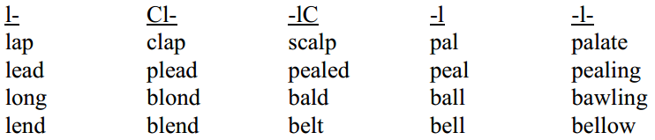

Outcome
In going through this drill you expect to improve your ability to produce this sound. In most cases the result will be control of this sound and ability to produce it without hesitation in running speech. If ths is going to happen successfully, it is you that will have to do it!
WORKSHEET 2 – Sound Contrast Drill

Introduction: This drill will help you focus your attention on, as well as hear the
difference between, similar sounds in the target language.

- Generally, you will want to construct this type of drill only if you already know there are two sounds that are almost alike and you tend to confuse one for the other. For example, learners of English may say beet for bit, or lace for race. It's helpful if you already have a pair that you can use to start your list.

- Identify a pair of sounds that you find difficult to distinguish between, whether in hearing the sounds or pronouncing the sounds correctly.

- With your helper make a list of minimal pairs in the language. These are words with different meanings that differ only in one sound contrast, such as like and mike. Try to come up with words that are used in everyday speech.

- Put the words into two columns, one for each sound. Here is an example of a minimal pair with the problematic sound in the middle position in the words:
/l/ /m/
let met
like Mike
light might
lime mime
lake make
luck muck

- You may use these lists to practice in a variety of ways, first listening, then producing the sounds. Here are a few ideas for how to use this drill:

- Ask your Language Helper to read down each of the columns. Then ask your LH to read across the columns so that you hear the contrasting sounds successively. (Examples: let, met; like, Mike; light, might, etc.) Listen carefully.

- Practice identifying the words. Ask you LH to say a word at random and you point to the column, indicating which column the target sound is located.
- Practice speaking. Ask your LH to say a word and you mimic the word. You may do this going down each column one at a time, across the columns or at random.

- Practice reading or saying the word. You read or say a word and the LH repeats the word correcting your pronunciation of the target sound, if necessary.

- Practice reading or saying the word. You say a word and the LH points to the column containing the word he/she heard. This exercise demonstrates if you are able to produce the sounds correctly.
- Record your helper reading each word, the first time going down the columns, saying each word three times and leaving enough time for you to repeat. Then have your LH read each item going across the columns, saying the item one time and leaving time for you to repeat.

- Transfer your recording to your computer and do whatever editing is needed in order to make your drill easier to use. Practice with your recording.

- See sample English vowel contrast drills http://usefulenglish.ru/phonetics/practice-vowel-contrast

SUPPLEMENT 1 – Alphabets
Alphabets ideally provide a unique symbol for each sound in a language. However, this is seldom the case. When creating single-sound drills and sound-contrast drills, you may sometimes have to resort to a foreign symbol, perhaps from English or from the IPA.

Khmer alphabet

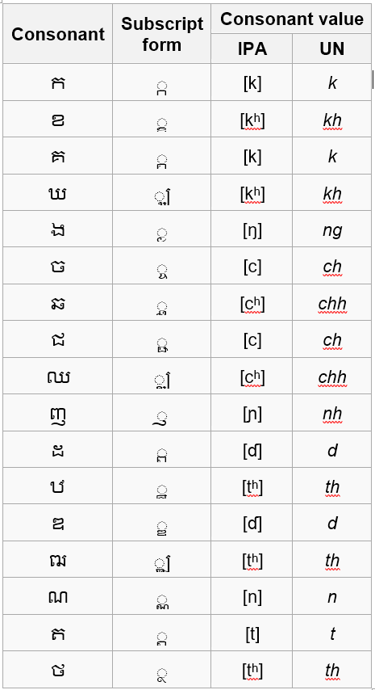 | 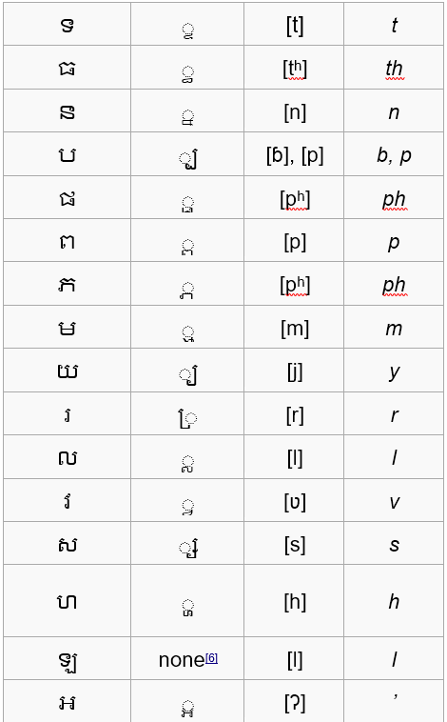

Turkish alphabet

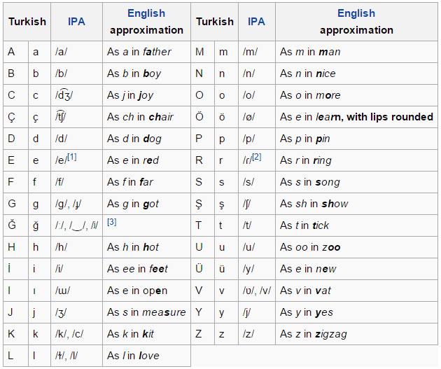

Thai Alphabet
