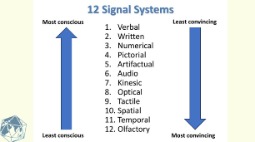
EXERCISE

What are some “redemption analogies” that you have found helpful in creating understanding?

What are some recommendations for testing redemptive analogies?
