FOUR FIELDS
A Nine-Session Workshop in Reproductive Methods of
Evangelism, Discipleship, Church Planting
and Leader Training

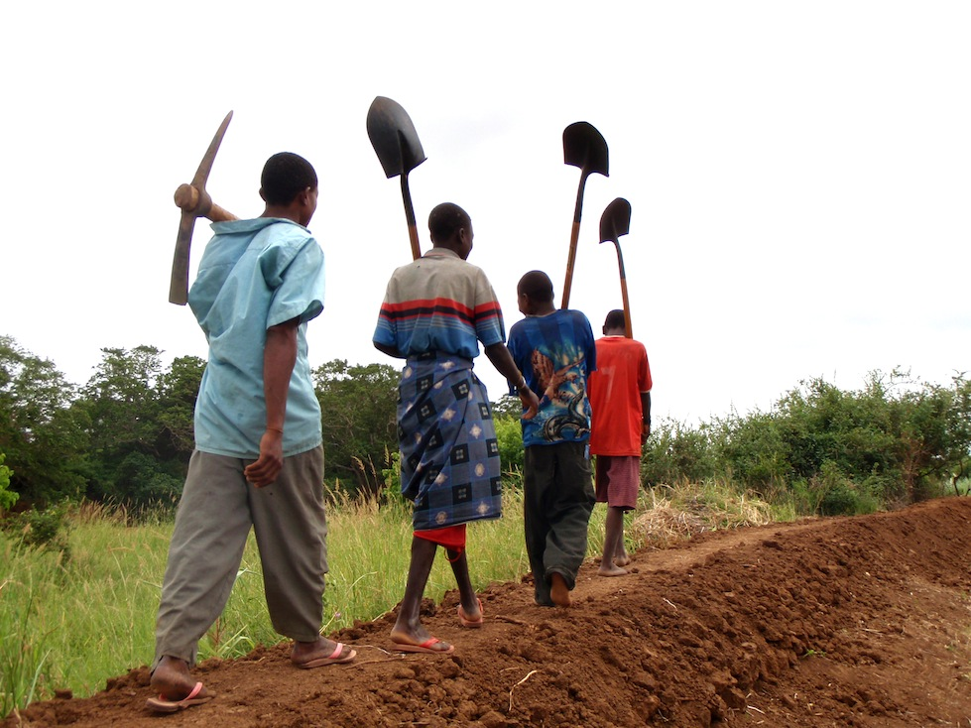

From People Of YES!
www.peopleofyes.com
October 2014

CONTENTS

INTRODUCTION 1
Module 1: “THE LORD’S VISION” 3
Module 2. THE EMPTY FIELD – GO! 5
Module 3. THE EMPTY FIELD – SEEK PERSONS AND HOUSES OF PEACE. 7
Module 4: THE EMPTY FIELD — PRAY FOR LABOURERS 9
Module 5: THE SEEDED FIELD — SHARE YOUR AND JESUS’ STORIES 11
Module 6. THE GROWING FIELD - PLANT SIMPLE CHURCHES 13
Module 7. THE HARVEST FIELD – PLANT MANY NEW CHURCHES 15
Module 8. THE HARVEST FIELD – MULTIPLY LEADERS AND TRAINERS 17
Module 9. MULTIPLY BELIEVERS, DISCIPLES, LEADERS AND TRAINERS 19

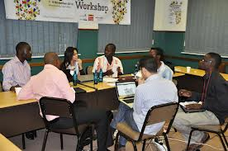

  - INTRODUCTION
This is a workshop guide for trainers of trainers within church-planting and disciple-making ministries..
Workshop — In a workshop, it is the learners who do most of the work, discovering insight from Scripture and making their own applications. As a workshop trainer, you introduce modules, provide guidance and makes suggestions.
Trainer — You are a trainer, but not a teacher. Your objective is to guide learners to discover insight for themselves. You are to employ simple methods that others can learn to imitate. You want all the learners to be able to train others, in the same way.
Learners — All who attend and participate in this workshop are learning two things: (1) The learn ideas from the Scripture, from you and from each other. (2) The learn how to present this same workshop to others, by following this manual.
Manual — Follow this manual carefully, without adding a lot more information. Present as much of the manual as you can, so that the learners will learn how to follow it when they train others. You yourself do not need this manual, but many of your learners will need it for a while. Have extra copies available for learners by buy at an affordable price.
Modules — You can present these modules in different ways. You may hold a two or three-day workshop in which learners complete two or more modules each day. Or you may present one module at a time, over several days or weeks.
Key verse — This is a bible passage that illustrates the subject of a module. Perhaps you could display this verse while presenting a module. Recommend to learners that they memorise this verse.
Big ideas — You should mention these ideas whenever they seem important, while presenting a module.
Role play — Find two volunteers who enjoy acting. Before each module or during breaks, coach these individuals in how to present their dialogue. Present the ideas and let each actor speak in his own words. No costumes or objects will be required. A dialogue usually happens in less than one or two minutes.
Bible discovery — Do not teach the recommend bible passages. Explain to learners that they are to divide up into tiny groups of three or four individuals. Assign a bible passage to each group. Members are to read the passage aloud together. Tell them all that they are to reply to the query; state the query several times, perhaps in different words. Next, groups members are to discuss answers to the query, then agree on a reply.
After four to seven minutes, one individual from each group tells one idea that his group’s members discovered. After all groups have reported, then each one may tell another idea. In this way, all groups get to report something before one group tells everything.
Discuss — Pose queries that elicit ideas from the learners. Affirm all useful ideas. If someone tells an idea that you cannot agree with, then you do not have to affirm it, but try not to humiliate the person who said it. Discussion is important, but do not take too much time for discussion.
Explain — This is your opportunity to teach a few good ideas or advice. Please, avoid trying to tell everything that your know about the subject.
Group work — Learners divide into tiny groups to talk about way in which they might apply their discoveries and other suggestions. They should write down brief plans, noting names, dates and places to carry out their plan. They should pray for each other and that God will help them to implement their plans.
Tools — If you are going to train in the use of pictures or other tools, be sure to have these on hand in advance. If you cannot obtain them in time, then present alternative methods, such as story-telling, song, and group discussion.
At the start of the workshop, or near the end of the workshop, provide a copy of this manual to every learner who agrees to follow it in training others. You may sell the manual to them for ab affordable price. Anyone may freely make photocopies of this manual and may freely translate it into other languages.

  - Module 1: “THE LORD’S VISION”
Key verse —"All authority in heaven and on earth has been given to me. Go therefore and make disciples of all nations, baptizing them in the name of the Father and of the Son and of the Holy Spirit, teaching them to observe all that I have commanded you. And behold, I am with you always, to the end of the age." Matthew 28:18-20
Aims —
Teaching objectives — Describe the Lord’s vision to multiply disciples who obey Jesus’ commandments.
Learning objectives — Learners agree with the vision, and can tell seven main commandments of Jesus.
Training outputs — Learner’s will pray and plan to make obedient disciples for the Lord Jesus.
Training outcomes — Increasing numbers of lost folk become disciples who obey Jesus’ commands.
Pastoral care — Form tiny groups. Members listen to each other and pray for each other’s needs.
Big ideas — propositions that summarize desired understanding by learners
- In his Great Commission, Jesus mandated the making of disciples
- Obedient disciples obey Jesus’ command to “make disciples..
- On-going disciple-making movements show us how to do the same.
Role play — Abba and Babba meet. Abba says: “The other religions demand that their disciples follow strict rules. What does the Christian religion require?” Babba replies: “After we make a decision for Jesus, we attend church services, listen to sermons, wear Western clothes, and bury our dead in a Christian cemetery.”
Discuss — Ask: Which parts of Babba’s reply are commandments of Jesus? (Best answer: None of them!)
Ask: What other common Christian activities did Jesus never command? (Listen to answers. Laugh together.)
Ask: What are some specific commandments of Jesus? (Affirm all right answers.)
Bible discovery — Tiny groups read together Matthew 28:18-20. They agree on an answer to this question: “What actions did Jesus command?” After four to seven minutes, each group reports. Best answers: God, Make disciples, Baptise, Teach, Obey.
Discuss — Ask: “What does it mean to teach?” (Listen to answers.)
Explain —
T — Tell. Tell specific commandments.
E — Example. Show how to obey.
A — Action. Lay action plans.
C — Coach. Help those who take action.
H — Hear. Listen to reports.
Explain — No one is a disciple until he has learned Jesus’ commandments and obeys them. Our task is to teach others to obey Jesus commandments. To do so, (1) we ourselves must obey them, (2) we show others how to do so, (3) we plan with them to do so, (4) we help them to do so, and (5) we empower them to do the same with others, in turn.
Group work — Tiny groups pray for each other’s ministry work to make many new disciples.
Discuss — Ask: “What are some of Jesus’ most important commandments?” (Listen to answers.)
Explain — These main commands of Jesus are the basis for his other ones.
- Repent, believe and receive the Holy Spirit
- Baptise and receive new believers
- Pray in my name
- Remember my death.
- Love God, neighbour, each other, and enemies.
- Give freely.
- Make disciples
Practice these seven commandments along with body motions. Ask for a volunteer to write a new song about these commandment, by tomorrow.
Group work — Form tiny groups. Have one volunteer recite seven commandments, showing body motions, while one person from each group mimics him. Next, have these do the same in his tiny group.
Transition — Explain briefly the “Four Fields” as an introduction to the rest of the training.
- Empty field, (2) Seeded field, (3) Growing field, (4) Harvest field
 |  |  |  | 
Repent | Believe | Receive Spirit | Baptise | Pray
 |  |  |  | 
Commune | Love God | Love others | Give | Make disciples

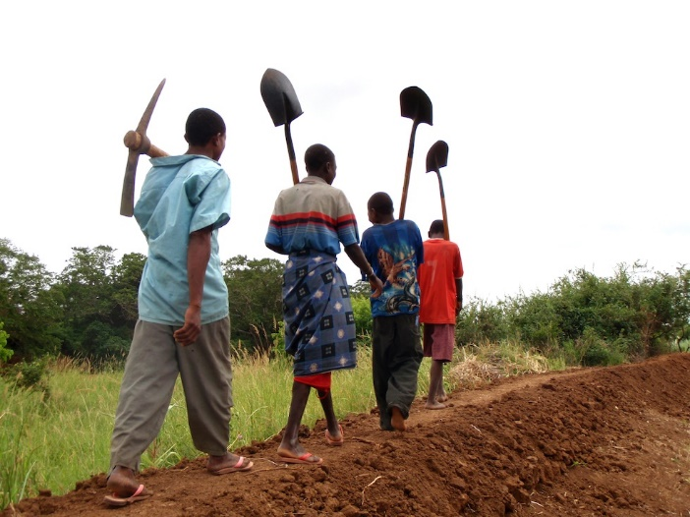
  - Module 2. THE EMPTY FIELD – GO!
Key verse — “The Lord appointed seventy-two others and sent them on ahead of him, two by two, into every town and place where he himself was about to go.” Luke 10:1
Aims —
Teaching objectives — Define an “empty field” and describe how to penetrate the same.
Learning objectives — Learners describe an empty field that they plan to penetrate.
Training outputs — Learners will implement a plan to penetrate an empty field.
Training outcomes — Families in an empty field believe the Good News.
Pastoral care — Form tiny groups. Members listen to each other and pray for each other’s needs. Members report on recent outcomes in their ministry.
Big ideas — propositions that summarize desired understanding by learners
- God calls you and your church to penetrate empty fields.
- Jesus has provided a plan for penetrating empty fields by entering homes.
- Bring entire households to faith in Jesus.
Role play — Abba and Babba meet. Abba asks: “Our church has been praying for workers to take the Good News to families in neglected places. What is your church doing about them?” Babba replies: “We have so many problems, that we must use all our time and finances to serve our members and strengthen our church. We leave evangelism and church planting to the missionaries.”
Discuss — In what ways can a church take care of its own members, while reaching out to neglected communities?
Bible discovery — Tiny groups read together Luke 10:1-10 and agree on a reply to this query: “What are the elements of Jesus’ plan to bring households to faith?” After four to seven minutes, each group reports. Best answers include: Pray up workers and send them out; provide no finances; enter homes; pray for healing; tell the Good News; leave the unresponsive.
Explain — How church planting movements train believers to keep the Good News flowing amongst lost folk:
- Train every believer to tell his own story and God’s story.
- Practice together telling one’s story and the original Good News.
- Identify persons or households with whom each one will go tell the Good News.
- Lay a plan to go do so.
- Return and report on what happened when they went and told the Good News.
- Empower obedient believers to train others to do the same.
Group work — Learners from tiny groups.
- Each member makes a list of names of individual or families to whom they will go tell the Good News.
- Each one writes a plan to go tell the Good News, indicating dates and places.
- Each one commits commitment to pray for each listed name, every day.
- Members pray for each other to follow their plan.
Reports from the field — Learners and describe challenges and report on experiences.
Bible discovery — Learners for tiny groups. Each group reads together one or two of the following passages: Luke 24:44-49; Acts 2:22-25; Acts 2:32-38; Acts 3:13-15; Acts 3:18-19, 26; Acts 5:29-32; Acts 10:38-43; Acts 13:28-33, 37-39; Acts 17:2-3; Acts 17:29-31; Acts 26:18-23; 1 Cor. 15:1-8. They agree on a reply to this query: “What are the main points of the Good News according to Jesus, Peter and Paul?” Each group reports.
Explain — The original Good News from Jesus and his apostles:
- Background: Old Testament Scriptures; works of the devil; John the Baptist; Jesus’ miracles.
- Message: Jesus crucified for human sins; buried; risen from death; appeared to witnesses.
- Invitation: Repent; believe; be baptized; receive the Holy Spirit; obey Jesus’ commandments.
- Promise: Forgiveness; Holy Spirit; eternal life; resurrection from death; reign with Christ.
Discuss — Which parts of the original Good News are most important to proclaim to local folk?
Do they believe in a Most High God? What do they believe to be the consequence of sin? What do they believe about the power of the devil? What do they believe about the next life? Do they practice sacrifice? What do they already know about Jesus? Do they practice ritual bathing?
Group work — Learners from tiny groups.
- Each member recounts the original gospel story to the other members.
- The members help each other remember the most important parts of the Good News.
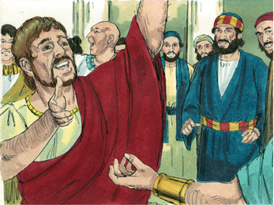

  - Module 3. THE EMPTY FIELD – SEEK PERSONS AND HOUSES OF PEACE.
Key verse — “On the following day they entered Caesarea. Cornelius was expecting them and had called together his relatives and close friends.” Acts 10:24
Aims —
Teaching objectives — Explain what persons of peace are, and how to find them.
Learning objectives — Learners understand what persons of peace are, and plan to find them.
Training outputs — Learners seek and find persons of peace.
Training outcomes — Persons of peace and their household believe the Good News.
Pastoral care — Form tiny groups. Members listen to each other and pray for each other’s needs. Members report on recent outcomes in their ministry.
BIG IDEAS
- God prepares men, women and households who receive evangelists into their home.
- Such “persons of peace” and their household become a “household church.”
- Churches in households draw friends, neighbours and family to Jesus.
Role play — Abba stops at a shop and orders a cup of tea.
Babba asks him, “You are a stranger in our town. Why have you come here?”
Abba replies, “I am a servant of the Most High God. I pray to him to help men and their families, and to heal their diseases.”
Abba then asks, “Would you like me to pray for your family?”
Babba replies, “My mother is sick. Can you come to my house this evening?”
Discuss — What happened in this play? What should Babba do next? How have you met such persons in your own ministry?
Bible discovery — Learners form tiny groups. Each group reads together one of the following passages: Luke 19:1-10 (Zacchaeus); Acts 10:21-33 (Cornelius); Acts 16:9-15 (Lydia); Acts 16:25-34 (Gaoler); Acts 17:1-9 (Jason); Acts 18:1-8 (Justus, Crispus). They agree on a reply to this query: “In what ways did Jesus and the apostles find and deal with persons of peace or houses of peace?” After four to seven minutes, each group reports.
Explain — Persons of peace:
P — Prepared by God
E — Eager to find God
A — Accept the Good News
C — Church in their house
E — Evangelise others, in turn
Discuss — Ask: “Where are places that your workers could meet persons of peace?”
Ask: “What should you do when you meet persons of peace?” (Good answers include: Offer to pray to the Most High God for the sick, for the oppressed and for other family needs. Offer to tell the Good News Story to their whole household. Arrange to baptise those who repent. Begin teaching them to obey Jesus’ commandments.)
Group work — Form tiny groups. Members discuss where to go to seek persons of peace. Each one plans dates on which to go to such places. Members pray for each other to find persons of peace.
Bible discovery — Learners form tiny groups. Member read together Acts 11:1-18. They agree on a reply to this query: “In what ways did Peter, who was a Jew, have to adopt new cultural practices in order to win non-Jews?” After four to seven minutes, each group reports.
Explain — Cultural difference
C — Customs, daily habits
U — Understanding, beliefs, values, authority
L — Language, heart, mind, will
T — Time, calendar, hours and events
U — Universal needs
R — Respect, esteem others as they are
E — Equal, in God’s sight
Group work — Learners form tiny groups. They discuss and reply to this query: In what ways will local believers have to adopt new cultural practices, in order to bring to Christ persons of peace and their families? After a few minutes, each group reports.

 |  |  | 
Satan binds households | Pray-walkers  bind Satan | Evangelists enter  houses of peace | House churches  reproduce

  - Module 4: THE EMPTY FIELD — PRAY FOR LABOURERS
Key verse — “The harvest is plentiful, but the workers are few. Therefore ask the Lord of the harvest to send out workers into his harvest.” Luke 10:2
Aims —
Teaching objectives — Convince learners to initiate prayer-walking as part of evangelism.
Learning objectives — Learners understand the power of prayer-walking for evangelism.
Training outputs — Learners lead believers who initiate prayer-walking in their new fields.
Training outcomes — Prayer-walkers break the spiritual bonds that hold the lost in unbelief.
Pastoral care — Form tiny groups. Members listen to each other and pray for each other’s needs. Members report on recent outcomes in their ministry.
Big ideas —
- Satan, “the strong man,” blinds the minds of the unbelieving who are captives of sin.
- By prayer-walking, believers can bind “the strong man” and free his captives.
- Prayer-walking can help you find a “person of peace.”
Role play — Abba and Babba meet and talk about Cabba Village.
Abba complains: “The inhabitants of Cabba Village are so wicked, that they could never believe in Jesus!”
Babba replies: “Jesus said, ‘No one can enter a strong man's house and plunder his goods, unless he first binds the strong man. Then indeed he may plunder his house’ (Mark 3:27).”
Abba asks: “But how? If we went there, they would stone us.”
Babba replies: “At such places, we must first conduct prayer-walks outside, before we go in. In that way, the Lord binds the local spirits so that folk there can hear the Good News.”
Discuss — Invite learners to share testimonials about binding spirits through prayer. Let two or three do so, and tell the rest to share with others during the break between sessions.
Bible discovery — Learners form tiny groups. Members read together one of these passages: Mark 9:17-29; Acts 13:2-12; Acts 16:16-30. They agree on a reply to this query: “In what ways can we believers bind evil spirits and set unbelievers free?” After about four to seven minutes, each group tells its bible story and reports its reply.
Explain — Prayer-walking:
W — Walk and talk normally
A — Ask God to bless households
L — Listen to the Holy Spirit
K — Knock down “fortresses”
I — In groups of two or three
N — Notice human needs
G — Go to neglected places
Group work — Learners form tiny groups. Each group leaves the meeting place, and goes on a twenty-minute prayer walk. They return and report on what the saw.
Role play — Coach five volunteer individuals in advance to act out this true story. These will pretend to be Grand-father, Mister Grumpy, his son Speechless, and two young women (or men).
The two young women prayer-walk in the room.
When they come near to Mister Grumpy, he asks, “What are you doing in our neighbourhood?”
They reply, “We pray to the Most High God to bless folk. Would you like for us to pray for your household?”
Grumpy sneers and says, “Yes. Come in and pray for my son. He was born mute and has never spoken.”
As the women pretend to pray over Speechless, be begins to say, “Ba-ba-ba-ba.”
Grand-father asks, “What?! Can he not speak our language?”
Speechless replies, “Of course, I can speak our language!” Grumpy calls several learners to come hear Speechless talk.
Then, Grumpy turns to the women and says, “Now, tell me about your God.”
Explain — prayer-evangelism:
E — Enter their home or place
V — View them as ripe and ready
A — Ask God to do the impossible
N — Name the Lord Jesus Christ
G — Give the Good News
E — Explain repentance and forgiveness
L — Lead them to be baptised
I — Instruct them in Jesus’ commandments
S — Stay or return and make disciples
E — Entrust this new church to the Lord
Group work — Learners form tiny groups and prayer for households to be saved. Each one writes a plan with dates to train and lead prayer-walking teams to neglected places.

 |  | 
Scripture | Miracles | Crucified
 | 
Buried | Risen
  - Module 5: THE SEEDED FIELD — SHARE YOUR AND JESUS’ STORIES
Key verse — “All authority in heaven and on earth has been given to me. Go therefore and make disciples of all nations, baptizing them in the name of the Father and of the Son and of the Holy Spirit, teaching them to observe all that I have commanded you. And behold, I am with you always, to the end of the age.” Matthew 28:18-20
Aims —
Teaching objectives — Instruct learners to telling both their testimony and the Good News.
Learning objectives — Learners memorize their story and choose an evangelism method.
Training outputs — Learners pray for a list of households, and present them the Good News.
Training outcomes — More households understand and respond to the Good News.
Pastoral care — Form tiny groups. Members listen to each other and pray for each other’s needs. Members report on recent outcomes in their ministry.
Big ideas —
- Every believer has a “personal story” of faith in the Lord Jesus Christ.
- Every believer knows of households where he can tell the Good News.
- Evangelism methods must prove affordable, reproducible, and culturally acceptable.
Role play — Abba meets with his friend Babba.
Abba confides, “I would like for others to come to faith in Jesus, but I do now know what to say to them.”
Babba asks: “Well, what has Jesus done for you?”
Abba replies: “For me? My whole household has got free from evil spirits, we have stopped abusing drink and drugs, we are a lot happier together, and we are no longer afraid to die.”
Babba advises: “Abba, tell others what you just now told me. Then tell them the Good News, and invite them to trust in Jesus and to get baptised.”
Bible discovery — Leaners form tiny groups. Members read together one of these passages: Acts 9:1-19; Acts 22:1-21; Acts 26:1-18. They agree on a reply to this query: “Tell (1) how Paul was before he believed; (2) how Paul believed in Jesus; and (3) how Paul became different after he believed.” After about four to seven minutes, each group gives a report.
Explain — Your own story (testimony):
S — Short. Less than a minute.
T — True. Tell what faith in Jesus has done for you and your household.
O — Orderly. (1) How you used to be; (2) how you believed; (3) how you are now different.
R — Ready. Memorize your story, so you can tell it to anyone.
Y — Your own. Tell your own story instead of telling about other believers.
Group work — Learners form tiny groups. Each member writes out his own story in three parts: (1) How he used to be; (2) how he believed; (3) how he is now different. Each one tells his story to the other groups members. They pray and ask God to help them tell their story.
Bible discovery — Leaners form tiny groups. Members read together one of these passages: Acts 8:26-39; 1 Corinthians 11:23-26. They agree on a reply to this query: What were some methods by which the apostles told the Good News?” After about four to seven minutes, each group gives a report.
Explain — Methods must be:
M — Memorable. It helps remember the story.
E — Easy to find. It is available to all who want it.
T — Teachable. Others can learn to use it.
H — Handy. It is easy to use anywhere.
O — Orderly. It follows the Good News story events.
D — Distinct. Hearers easily understand from it.
Demonstration — How to employ a particular method in presenting the Good News story.
- Presenters tell the Good News by employing the method, while learners watch.
- Presenters help volunteers to tell the Good News by employing the method.
- Learners tell the Good News by employing the method, while presenters watch.
Group work — Learners form tiny groups. Each members tells the Good News to other members, employing the method. The others help him if he forgets something. Each one repeats this until all are able to tell the Good Nest, employing the method.
Group work — Learners form tiny groups.
- Each member plans to go tell the Good News to unbelievers, employing the method.
- Each member plans to train other believers to tell then Good News., employing the method.
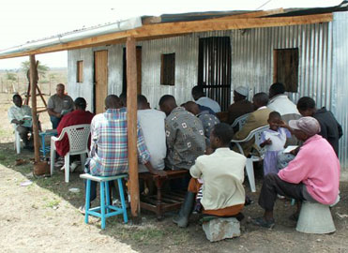

  - Module 6. THE GROWING FIELD - PLANT SIMPLE CHURCHES
Key verse — They entered Lydia's house, and when they saw the brothers, they encouraged them and then departed. Acts 16:40
Aims —
Teaching objectives — Instruct learners in the starting and leading of simple churches.
Learning objectives — Acquire confidence and minimal church planting skills.
Training outputs — Learners adopt simple church planting as part of their ministry work.
Training outcomes — Simple churches multiply and make disciples, everywhere.
Pastoral care — Form tiny groups. Members listen to each other and pray for each other’s needs. Members report on recent outcomes in their ministry.
Big ideas —
- A church is Jesus Christ in the midst of those who obey his commandments.
- Simple churches discover truth, and teach obedience to Jesus’ commandments.
- Existing and new believers, even unbelievers, can start simple churches.
- Make disciples by teaching and empowering them to obey all of Jesus’ commandments.
Role play — Pastor Abba and Pastor Babba meet to talk.
Abba complains: “Most seekers and new believers, who start attending my church services, soon stop coming. And most of them go back to their old religion and sins.”
Babba replies: “The same things used to happen in my church, but no longer. Now, most seekers and new believers learn the Bible fast, and most remain faithful to their church.”
Abba asks: “What have you done to solve the problem?”
Babba answers: “We form seekers and new believers into simple, little churches, in which they themselves discover from the Bible what they should believe and what they should do.”
Abba exclaims: “But it takes years to start and develop a church, does it not?!
Discuss — Ask: “What are some activities and traditions of big churches that the Bible does not require?” Let anyone reply; agree with any good answer. (Good answers include: buildings, budgets, bible schools, benches, big groups, books, sermons, clergy, constitution or bylaws.)
Bible discovery — Learners form tiny groups. Each groups reads together one of these passages: Matthew 18:18-22; Acts 14:21-23; 1 Corinthians 14:24-26. They agree on a reply to this query: “What are the necessary parts of a simple church?” After four to seven minutes, each groups gives a report.
Explain — Simple church
S — Serve the Most High God
I — Invite Jesus into our midst
M — Make obedient disciples
P — Pray in Jesus’ Name
L — Learn the Bible together
E — Elders lead by example
C — Christ is our only Lord
H — Help each other
U — Urge each other
R — Reach out to others
C — Churches gather anywhere
H — Household evangelism
Group work — Form learners into temporary, simple churches.
- Learners from tiny groups with whomever they like.
- Each group prays to invite Jesus into its midst.
- Each church chooses a temporary shepherd. (Appoint these with prayer.)
- Each church celebrate communion in a very simple way.
- Each church does the next Bible discovery.
Bible discovery — Learners form tiny groups. Each group reads together Acts 14:37-47. They agree on a reply to this query: “In what ways did the first churches obey Jesus commandments?” After four to seven minutes, each groups gives a report.
Explain — Obedience
O — Only what Jesus requires is what we require.
B — Behave in ways that Jesus and his apostles said.
E — Every believer is free to obey Jesus along with others.
Y — You train and empower others to obey.
Group work — The simple churches write simple plans, noting places and dates.
- to teach new disciple to obey Jesus’ basic commandments
- to form households into simple churches
- to appoint temporary elders in simple churches
  - Module 7. THE HARVEST FIELD – PLANT MANY NEW CHURCHES
Key verse — The church throughout Judea, Galilee, and Samaria experienced peace and thus was strengthened. Living in the fear of the Lord and in the encouragement of the Holy Spirit, the church increased in numbers. Acts 9:31
Aims —
Teaching objectives — Instruct in steps to take in planting a new church.
Learning objectives — Learners describe steps to take in planting a new church.
Training outputs — Learners initiate steps to plant new churches.
Training outcomes — Learners’ plant new churches that make disciples.
Pastoral care — Form tiny groups. Members listen to each other and pray for each other’s needs. Members report on recent outcomes in their ministry.
Big ideas —
- There are many models and definitions of what a church is.
- Church planting normally follows evangelism and disciple-making.
- Any group that has certain biblical characteristics may be called a church.
Role play — Pastor Abba comes to see his friend, Pastor Babba.
Abba: “A bishop from another denomination has told me that my new small groups should never be called churches.”
Babba: “Why is that? What does he require a group to do, in order to become a real church?”
Abba: “He says that real churches must gather in a chapel, have a paid pastor, collect tithes and offerings, be approved by a denominational office, and get registered with the government.”
Discuss — Ask, “What does the New Testament require of a group before it can be called a church?” Approve of all good answers. (Some good answers include: baptised members, gather in Jesus’ name, obey together Jesus’ basic commandments, teach the Bible, and appoint one or more elders.)
Bible discovery — Learners gather in their tiny churches. Each groups reads together one of these passages: Acts 14:21-23; Ephesians 1:17-23; Ephesians 3:16-21; 1 Timothy 3:14-16; 1 Timothy 4:13-16. They agree on a reply to this query: “What are some marks, traits or characteristics of churches?” After four to seven minutes, each groups gives a report.
Explain — Churches
C — Christ’s beloved bride
H — Headship of Christ
U — Until Christ return
R — Read and teach Scripture
C — Continue in the faith
H — Hope of eternal inheritance
E — Elders lead and prophesy
S — Saints perform righteous deeds
Group work — Learners gather in their tiny churches. They describe to each other their various small groups, house churches and discipleship cells. They pray for these and lay a plan to recognise certain ones as church congregations.
Role play — Pastor Abba comes to see his friend, Pastor Babba.
Abba: “Several of our small groups and discipleship cells seem to have the biblical characteristics of churches. But we do not know how to make them into recognised churches.”
Babba: “Your denominational officers or ministry leaders should be able to give you advice.”
Abba: “But the civil authorities in our region will not register any new churches, because the other religions cause problems.”
Babba: “Most new churches round the world are not registered with their government. It is enough that other churches recognise new churches.”
Explain — Officially recognise new churches. If your denomination or ministry does not have an official recognition process, then you may adapt the following steps.
- Coach the acting elders to teach the believers about the church from the New Testament.
- Meet with the believers and agree on a date and place for a celebration, when they will be officially recognised as a church.
- Arrange for elders and believers from other churches to gather for a celebration.
- Arrange for some denominational and ministry leaders to come to the celebration.
- Gather for the celebration, in a culturally-appropriate way. Perhaps serve a meal.
- Have some believers testify to all about how they have come to faith in Christ.
- Have one or two officials present a bible message about the eternal future of the church.
- Have someone tell the history of evangelism, disciple-making and leader training. Name the ministry leaders, evangelists, church-planters and others who served these believers.
- Have several all the local believers and their elders stand together, and have a denomination or ministry leader pronounce them to be a church, and present them with an official letter, banner or other cultural artifact.
- Have two or three officials and pastors pray over the new church and its elders.
Bible discovery — Learners gather in their tiny churches. Each groups reads together one of these passages: Hebrews 12:22-24; Revelation 21:1-9; Revelation 21:9-11. They agree on a reply to this query: “What will God do in the future for churches?” After four to seven minutes, each groups gives a report.
Explain — Glory
G — Gathered to Jesus to enjoy him forever as our intimate friend.
L — Lord Jesus reigns over an eternal kingdom, and we reign with him.
O — Our faith, love and work for Christ’s church earn eternal rewards.
R — Reserved inheritance in heave that will never fade.
Y — Your own place with the Bride of Christ in the eternal City of God.
Group work — Learners gather in their tiny churches. They plan to teach new disciples about their eternal future. They note dates and places. They pray for new churches.
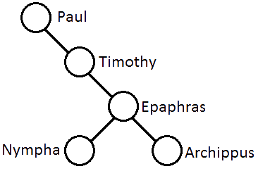
  - Module 8. THE HARVEST FIELD – MULTIPLY LEADERS AND TRAINERS
Key verse — “entrust what you heard me say in the presence of many others as witnesses to faithful people who will be competent to teach others as well.” 2 Timothy 2:2
Aims —
Teaching objectives — Illustrate biblical principles for developing new leaders and trainers.
Learning objectives — Able to project new generations in linages of trainers training trainers.
Training outputs — Learners begin coaching faithful men and training new trainers.
Training outcomes — Networks and linages of coaches and trainers keep growing.
Pastoral care — Form tiny groups. Members listen to each other and pray for each other’s needs. Members report on recent outcomes in their ministry.
Big ideas —
- Jesus and his apostles trained new workers by coaching them on the job.
- Wise pastors personally coach church members who share in pastoral work.
- Churches multiply only as fast as leaders train up new leaders who do the same.
- The best trainers are those who learned their work by doing it faithfully.
Role play — Abba comes to see Babba to ask a favour of him.
Abba: “Babba, you have been a good coach for me, and given me much good advice. My church has started some new churches, and they need good shepherds. Will you, please, coach new leaders for our new churches?”
Babba: “I do not have time to do so. But you, Abba, you can train them yourself, in the way that Jesus and his apostles trained new workers.”
Abba: “But I do not have enough wisdom and I lack many skills. How could I do so?”
Discuss — Ask: “What were some of the ways in which Jesus and his apostles trained up new leaders, new church planters and new trainers?” (Good answers: coaching, generations of trainers, planning together, learning what is needed on the job, writing epistles.)
Bible discovery — Learners gather in their tiny churches. Their shepherd leads them to read together one of these passages: Mark 3:13-19; Mark 6:7-13 and 30; Colossians 1:1-8; Colossians 4:12-18. They agree on a reply to this query: “How many generations of workers report to each other?” After four to four to seven minutes, each shepherd reports.
Group work — Learners form tiny groups. Members name individuals whom they coach personally, or whom they will start to coach. Each one draws a diagram showing (1) himself, (2) someone who coaches him, and (3) those whom he coaches or will start coaching.
Explain — Coaching process: (1) Meet and share reports; (2) Ask God for wisdom; (3) Agree on a new plan; (4) Assign reading; (5) Review learning; (6) Practice new skills; (7) Intercede for families and workers.
Role play — Abba comes to ask advice of Babba.
Abba: “My nephew has just graduated from Bible school and needs a job. Could the ministry organisation hire him as a trainer? He has studied Greek language.”
Babba: “We thank God for competent bible scholars. However, has your nephew made many disciples? Has he planted a church? Has he coached new leaders?”
Abba: “I do not think so. What are the qualifications for trainers?”
Bible discovery — Learners gather in their tiny churches. Their shepherd leads them to read together 2 Timothy 2:1-2. They agree on a reply to this query: “What was the apostle Paul’s method for raising up trainers?” After four to seven minutes, each shepherd reports.
Explain — Faithful person
F — Follows agreed plans
A — Attends training sessions
I — Identifies learning needs
T — Trains others, in turn
H — Has planted churches
F — Feeds on God’s Word
U — Understands authority
L — Leads cells or churches
Group work — Learners form tiny groups. Members pray for many more experienced trainers. They name individuals whom they will help train to train others in turn. They pray for these by name. They plan to hold model training workshop, noting places, dates and attenders.

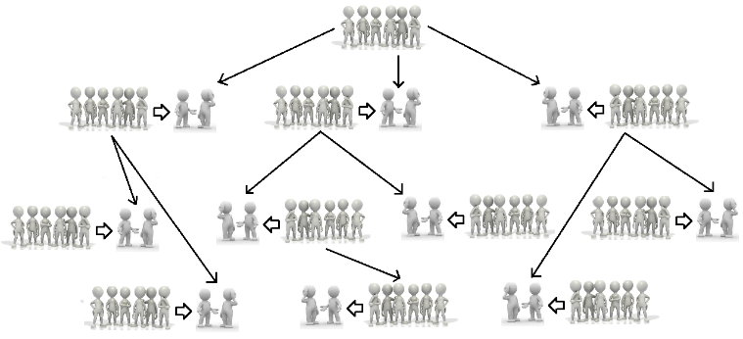

  - Module 9. MULTIPLY BELIEVERS, DISCIPLES, LEADERS AND TRAINERS
Key verse — “This went on for two years, so that all who lived in the province of Asia, both Jews and Greeks, heard the word of the Lord.” Acts 19:10
Aims —
Teaching objectives — Review the vision, methods and means of continual expansion.
Learning objectives — Understand how all the pieces of this training workshop fit together.
Training outputs — Learners implement this workshop as part of a continual training ministry.
Training outcomes — Entire regions and people groups hear the Word of the Lord.
Pastoral care — Form tiny groups. Members listen to each other and pray for each other’s needs. Members report on recent outcomes in their ministry.
Big ideas —
- Every harvest requires good seed, workers, soil, planting, water, tools and weeding,
- Every growing flock requires shepherds, sheep, food, water, protection and mating.
- Every movement requires continual training in evangelism, discipleship and leadership.
- Every ministry must track its ministry outcomes, to keep making right decisions.
Role play — Abba and Babba report on progress in their ministry.
Babba: “Abba, what have been the results after attending the training workshop?”
Abba: “Babba, we have done everything that we learned in the training workshop, but our churches are neither growing nor multiplying. I have concluded that the workshop methods do not work.”
Babba: “How many times have you tried all the methods?”
Abba: “We did everything one time. We held one training session. We went out once and told the Good News. We identified one person of peace. We made one disciple. We even held one discover bible study. But the results have stopped.”
Discuss — Ask: “What did Abba’s workers do rightly?” and, “What did Abba’s workers do wrongly?” then, “What would you recommend to Abba and his workers?”
Bible discovery — Learners gather in their tiny churches. Their shepherd leads them to read together one of these passages: Acts 19:1-10; Acts 20:27-35; 2 Timothy 2:1-10. They agree on a reply to this query: “For how much time must we keep working and training, to get the results that we seek?” After four to seven minutes, each shepherd reports.
Group work — Learners gather in their tiny churches. They review all the plans they have written in previous sessions. They discuss together how they can cooperate with each other, to keep on training others for one, two or three years.

Role play — A year later, Abba and Babba report again on progress in their ministry.
Babba: “Abba, what have been the results after a year of training many believers?”
Abba: “After a year, nearly every day, we see folk come to faith and learn to obey Jesus. We start new house churches almost every week, and we train new shepherds all the time.”
Babba: “That is wonderful. But how do you know what to do? And how do you know whom you can rust to do the work of ministry?”

Discuss — “What kinds of information do you require in order to make good decisions, to lay good plans?”
Bible discovery — Learners gather in their tiny churches. Their shepherd leads them to read together several of these passages:
Acts 2.41-42 6.1 12.14 2 Cor 10.15-16
Acts 2.47 6.7 13.48-49 Matt 28:29-20
Acts 1.8; 5.14; 9.31; 19.20
Acts 11.24; 16.5; Rom 16.8-10.
They agree on a reply to this query: “For how much time must we keep working and training, to get the results that we seek?” After four to seven minutes, each shepherd reports.
Discuss — The apostles tracked and reported on baptisms, disciples added, increasing or multiplying, the same for churches, reaching which social classes, cities and regions, and approximate dates.
Explain — Outcomes mapping
 | 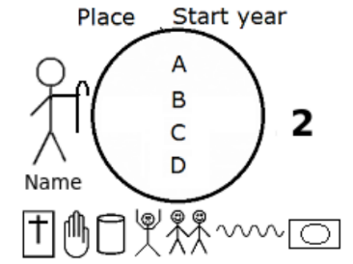 | 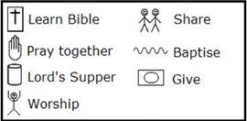
Group work — Learners gather in their tiny churches. They draw a map of the churches that they currently supervise. The identify co-workers whom they will teach to draw such maps.
Conclusion — Everyone sets their maps in their midst, and they hold of season of serious prayer, asking God to multiply their believers, disciples, churches, leaders and trainers.

Since English has the word ‘household,’ it remains unnecessary to introduce the Greek word ‘oikos.’

